Exercises grade 5 week 24

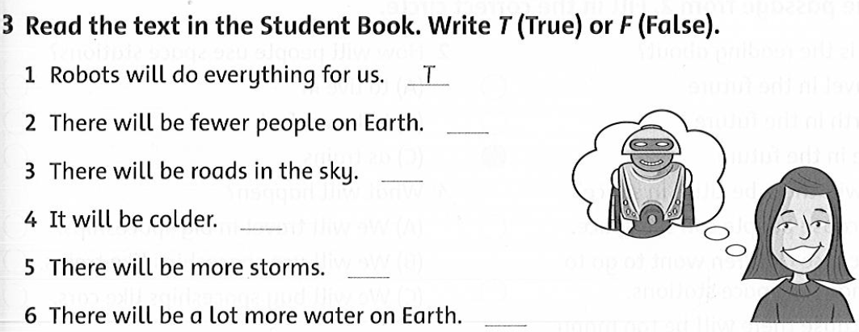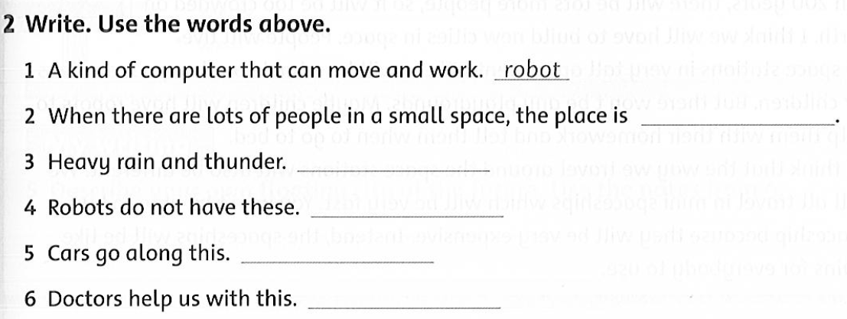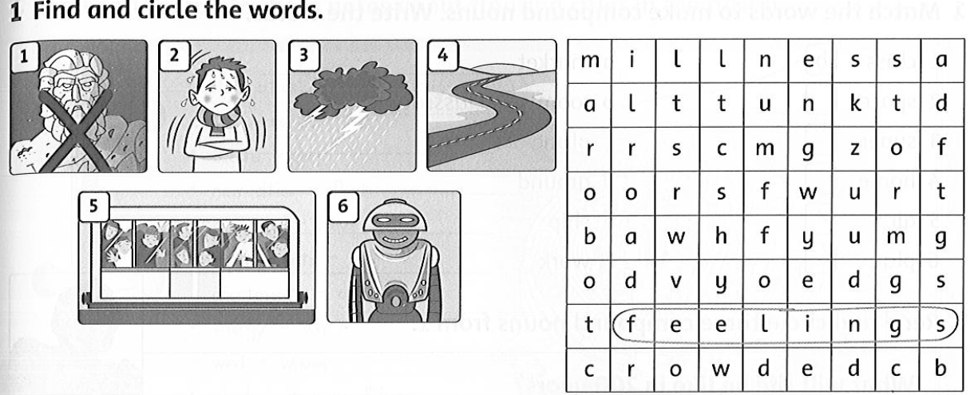Unit 9 Reading

ANSWER KEY

Grade 5 unit 9 Reading

1. Circle he words

1. Feeling 2. illness 3. storm 4. road 5. crowded 6. Robot

1. Write the words
2. robot 2 .crowded 3. storm 4. feelings 5. road 6. Illness
3. T/ F?

1.T 2. F 3.T 4. F 5. F 6.T